Homework 5
Astro 610 – Jay Franck
In order to find a linear ephemeris for a binary system with data from approximate eclipse timings (times of minimum light), we must utilize a Least Squares fitting. As derived previously in #1, the basic idea is to minimize the difference between the observed values that are given, and the values generated by the linear model that was computed. The form of the linear model to be used is
y=To+(P*E), where y is the time of minimum intensity, To is the time of the 'first' cycle, P is the period of the system, and E is the cycle count. We apply the standard linear regression form y=A+Bx, where A and B must be calculated to fit the values of y and x.
With two unknowns (To+P), the first step is to find a range of values that could possibly fit the data. The smallest time difference between two times of minimum intensity must be a maximum value for the range of trial periods, and given information stated that the period was greater than 2 days. Calculating the minimum difference and doubling it (to account for observational errors and possible spurious periods), a list of 99,995 trial periods was generated between the range of (2,7). With a chosen To of 37968.3438 and the large list of trial periods, a Chi-squared test was utilized to measure the find the best value of the period that fit the data (where the best values are found when this equation is at a minimum). The cycle count can be found using . An initial value of the period was found to be 3.4362 which a χ=51.865.
With this initial period found, values of A and B could be optimized to fit the data. Using the derivations found in part #1, the period P= 3.4362 found in the iteration sequence, and To= 37968.3438, B was calculated to be 3.43611497613 days, while A was found to have a value of 37969.4019464. Utilizing the 1σ derivations from Wolfram's MathWorld: and
were used for the errors in To and P, respectively. The final values calculated, with errors, are To(A)= 37969.4019464±0.0343771 and P(B)= 3.43611497613±2.81548724575e-05.
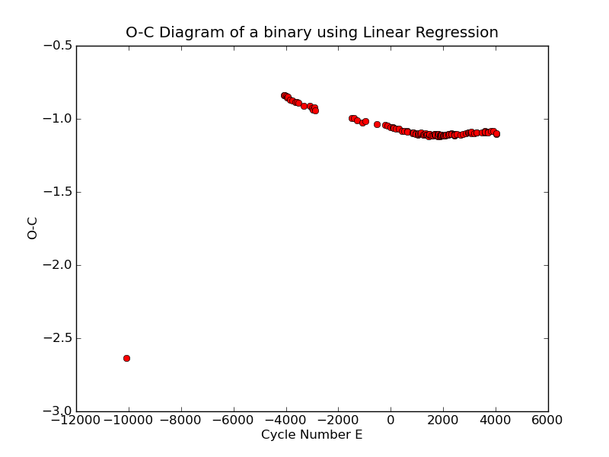
It seems that the residuals increase as the Cycle Number increases, which may be from a change in the period over time, or maybe because the system is interacting in some way (I.e. contact binary, Roche-lobe overflow, third body, etc.)

References
Taylor, John R. An Introduction to Error Analysis. 2nd Edition. 1997, University Science Boos.
Weisstein, Eric W. "Least Squares Fitting." From MathWorld--A Wolfram Web Resource. http://mathworld.wolfram.com/LeastSquaresFitting.html

